
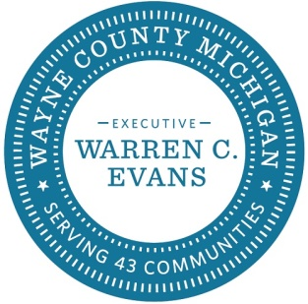

July 30, 2026

Dear Wayne County Retiree:

Our records indicate that as of October 1, 2018, you have $<merge amount> remaining in your HRA Account. These funds are designated for you to spend on your eligible health and medical expenses.

Eligible Expenses
You can be reimbursed for medical and Rx insurance premium as well as 213(d) expenses. Examples of 213(d) expenses include Medical and prescription drug deductible expenses, drug copays, eligible over-the-counter drugs, eyeglasses, dentures, hearing aides and batteries and more.

Filing a Claim
There are different ways you can file a claim to access your funds. You can either submit a Reimbursement form or use your HRA debit card. More information is located in the enclosed FAQ.
HRA Reimbursement Forms
Reimbursement Forms have been included in this package for your convenience. The forms should be returned directly to Genesis for processing.

Medical and Rx Coverage
If you are seeking Medical or Rx coverage, please contact AmWINS or email service.WayneCounty@amwins.com to request an electronic kit.

If you have any questions regarding your coverage or your HRA, please call the AmWINS Group Benefits Customer Care Center toll-free at 1-877-847-9906, Monday through Friday, 8:00 AM to 8:00 PM (EST).

Sincerely,

AmWINS Customer Care Center

