VOLUNTARY LABOR ARBITRATION TRIBUNAL EXPEDITED ARBITRATION

WAYNE COUNTY RETIREE SUB-CHAPTER 38, AFSCME

-and- WAYNE COUNTY
Macdonald Settlement Grievance # 8

APPEARANCES

For the Sub-Chapter: Miller Cohen, PLC by Robert Fetterer, Esq. For the Employer: Bruce A. Campbell, Esq., Lead Attorney

AWARD of the ARBITRATOR

I, THE UNDERSIGNED ARBITRATOR, having been designated in accordance with the SETTLEMENT AGREEMENT AND RELEASE entered into between the above-named parties, and having carefully considered the evidence that was submitted and the arguments that were made, do hereby AWARD, as follows:

BACKGROUND

- The Parties entered into a Settlement Agreement on or about June 2, 2015, on behalf of themselves and on behalf of all bargaining unit employees who retired from Wayne County before December 1, 1990, or who retired on or after December 1, 1990 and whose health insurance benefits from the County, were established and modified by the 1990 Wayne County Health and Welfare Benefit Plan.

- The Settlement Agreement provides, among other things, for a Grievance Procedure culminating in arbitration to resolve disagreements regarding the meaning or application of any provision in the Agreement. This Bench Opinion is rendered in accord with the Agreement and is final and binding on the parties.

- Grievance #8, filed on April 15, 2019, complains that Wayne County acted unilaterally to create a Health Reimbursement Arrangement (“HRA”), the Plan Document of which, the Sub-Chapter alleges, is inconsistent with the terms of the Settlement Agreement as applied to Medicare-eligible retirees. The expressly identified inconsistencies are:

  - The unused portion of the HRA accounts reverts to the County;
  - The County reserved the right to make unilateral changes, interpretations, and termination of the plan;
  - There are conditions on participation that were not anticipated.

- In its grievance, the Sub-Chapter seeks the following remedy:

  - that Wayne County meet with the Sub-Chapter on a regular and meaningful basis to develop a stipend plan that conforms to the settlement agreement and all applicable state and federal regulations,
  - that Wayne County provide all eligible class members with an agreed upon summary plan document prior to the agreed upon date for implementation of the new stipend plan,
  - that the upon implementation of the new stipend plan the unilaterally implemented HRA plan be dissolved,
  - that Wayne County compensate all class members that were harmed by the unilaterally implemented plan,
  - that Wayne County take all other actions to make the Sub-Chapter and the class whole for the violation of the Settlement Agreement.

- The County denied the grievance on June 5, 2019, stating, in part, that it had met with representatives of the Sub-chapter, that the plan is intended to maximize retiree stipends by distributing the stipends through an appropriate tax-exempt plan, and that it was consistent with the terms of the Settlement Agreement.

FINDINGS

- The Sub-Chapter and the County agreed, “The Parties recognize and acknowledge that the healthcare benefits referenced in the 1990 HWBP and the underlying labor agreements are not accrued financial benefits but that the monetary stipends provided under this Agreement shall be treated as an accrued financial benefit for Class Members.” In addition, they agreed that “Class Members and their eligible dependents are entitled to the accrued financial benefits represented by the monetary stipends described in this Agreement for the remainder of their lives.”

- The Basic Plan Document and its accompanying Adoption Agreement provide for forfeiture of the account upon the death of the participant, with reversion of these amounts to the County. It further provides that the County may use these funds to pay the Plan’s administrative expenses, or for any other purpose allowed by law.

- The Settlement Agreement provides, “The County, at its sole discretion, has the right to employ procedures to carry out the administration of the stipend program, including but not limited to all tasks necessary to verify and modify eligibility of Class members under the rules set forth in this Agreement.”

- The reversion of a contribution to the contributor appears inconsistent with the concept of an accrued financial benefit. The change complained of herein is not a procedure by which the administration of the stipend program will be carried out but is a substantive change of a term of the Agreement that financially impacts members of the Sub-Chapter. The unilateral imposition of this term by the County was inconsistent with the Settlement Agreement.

AWARD

- For the foregoing reasons, the grievance is GRANTED. The relief sought in the grievance is awarded in part, and as follows:

  - Wayne County must meet with the Sub-Chapter on a regular and meaningful basis to develop a stipend plan that conforms to the settlement agreement and all applicable state and federal regulations;
  - Wayne County will provide all eligible class members with an agreed upon summary plan document prior to the agreed upon date for implementation of the new stipend plan;
  - Upon implementation of the new stipend plan or March 10, 2021, whichever is earlier, the unilaterally implemented HRA plan will be dissolved unless the parties agree to retain the current plan; and
  - Wayne County will compensate all Medicare-eligible class members that were harmed by the unilaterally implemented plan.

The arbitrator shall retain jurisdiction for the sole purpose of implementing this Award and resolving any questions over the application or interpretation of the remedy that may arise under it.

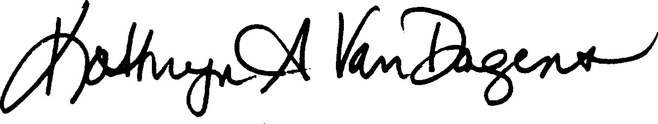
February 10, 2020 Date Kathryn A. VanDagens, Arbitrator

